CS 5348
Operating System Concepts
Project 1 Summary
Exploring Multiple Processes and IPC

Name : Madhusudan Pranav Venugopal
netid: mxv130430
UTD ID: 2021163441

Project purpose:
The purpose of the project was to simulate a simple computer system consisting of a CPU and memory using Unix operating system processes created using Unix fork () and communicate using IPC (pipe). The objectives of the project were to understand concepts such as processor interaction with main memory, processor instruction behavior, role of registers, stack processing, procedure calls, systems calls, interrupt handling, memory protection and I/O.
The project had to satisfy the following conditions:
CPU
It will have these registers: PC, SP, IR, AC, X, Y.
It will support the instructions shown on the next page of this document.
It will run the user program at address 0.
Instructions are fetched into the IR from memory. The operand can be fetched into a local variable.
Each instruction should be executed before the next instruction is fetched.
The user stack resides at the end of user memory and grows down toward address 0.
The system stack resides at the end of system memory and grows down toward address 0.
The program ends when the End instruction is executed. The 2 processes should end at that time.
The user program cannot access system memory (exits with error message).

Memory
It will consist of 2000 integer entries, 0-999 for the user program, 1000-1999 for system code.
It will support two operations:
read(address) returns the value at the address
write(address, data) writes the data to the address
Memory will initialize itself by reading a program file.
Timer
A timer will interrupt the processor after every X instructions, where X is a command-line parameter.

Interrupt processing
There are two forms of interrupts: the timer and a system call using the int instruction.
The stack is switched to the system stack.
Registers should be saved on the system stack.
A timer interrupt should cause execution at address 1000.
The int instruction should cause execution at address 1500.
Interrupts should be disabled during interrupt processing to avoid nested execution.
The iret instruction returns from an interrupt.

Project Implementation:
The project was implemented in C++ language with Unix operating System as the platform. The project was designed to accept a sample test filename along with the interrupt timer value as command line arguments.
The project has the following stages in it:
1. Reading from the sample test file and storing it in the memory array
2. Fetching each instruction one by one from the memory array after the execution of the previous instruction was over.
3. The communication between the pipes was achieved using pipes as the means of inter-process communication
4. Stacks were used to store the register values during the processing of interrupt. There are two stacks ( one residing at the end of the user program memory area and other at the end of the system program memory area)
Output :
The output for the various sample test files are as follow:
Sample1.txt
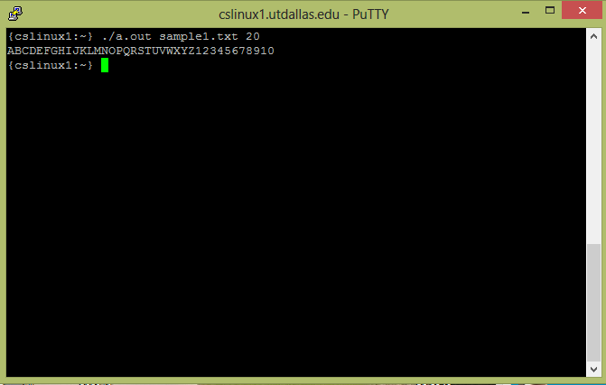

Sample2.txt
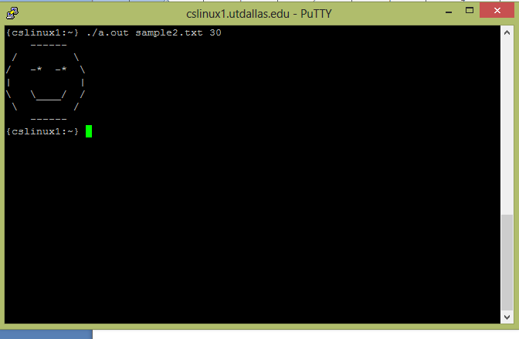

Sample3.txt
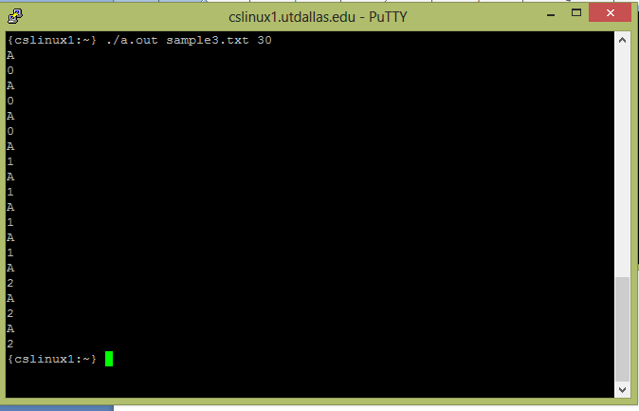
Sample 4.txt
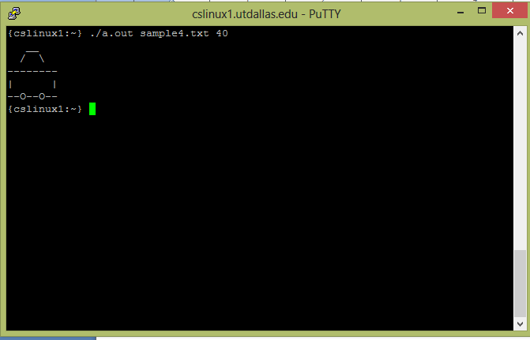
Personal Experiences:
A lot of difficulties were faced and overcame during the implementation of the project. Some of the difficulties experienced were debugging the code for small semantics and logical errors. These errors were discovered and corrected when the code was executed line by line. For the line by line execution of the code, gdb compiler and debugger was used. I had to spend some time reading about gdb compiler in the Internet in order to use it for the line by line by execution and debugging of the program code.
I could design the 4th sample test file only after understanding the first 3 sample cases fully . A lot of trial and errors attempts too was involved during the designing of the 4th sample test case.
References:
For the concepts of process creation using Unix fork() and Inter-Process Communication (IPC) using pipes , the examples shown and put up in e-Learning was used as reference.
For line-by-line execution and debugging of the code using gdb, the following websites were used:
https://sourceware.org/gdb/onlinedocs/gdb/Logging-Output.html
https://sourceware.org/gdb/onlinedocs/gdb/Forks.html
https://sourceware.org/gdb/onlinedocs/gdb/Inferiors-and-Programs.html#Inferiors-and-Programs
http://www.cs.swarthmore.edu/~newhall/unixhelp/howto_gdb.html
For the ASCII values used during the designing of the 4th sample test file, the below website was used as reference
http://www.asciitable.com/

